







1:[Bahrain](http://en.wikipedia.org/wiki/Bahrain), [Oman](http://en.wikipedia.org/wiki/Oman), [Mahra](http://en.wikipedia.org/wiki/Al_Mahrah_Governorate) and [Yemen](http://en.wikipedia.org/wiki/Yemen)  
2 *:Origin and development of the Qur'an*3 :Military expansion



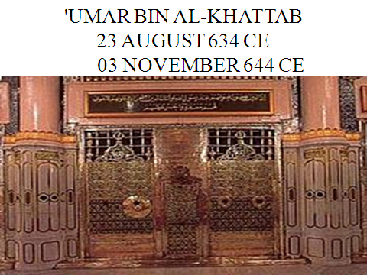

* **Katib, the**[**Chief Secretary**](http://en.wikipedia.org/wiki/Chief_Secretary)**.**
* **Katib-ud-Diwan, the Military Secretary.**
* **Sahib-ul-Kharaj, the Revenue Collector.**
* **Sahib-ul-Ahdath, the**[**Police chief**](http://en.wikipedia.org/wiki/Police_chief)**.**
* **Sahib-Bait-ul-Mal, the**[**Treasury**](http://en.wikipedia.org/wiki/Treasury)**Officer.**
* **Qadi, the**[**Chief Judge**](http://en.wikipedia.org/wiki/Chief_Judge)**.**





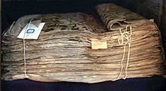

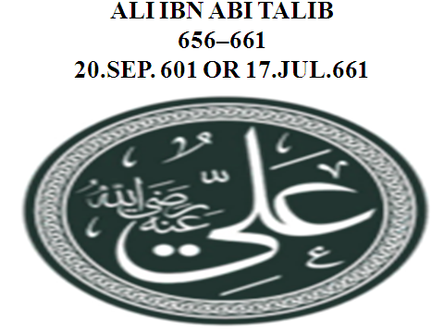

**Abbasid Empire 750-1258**

|  |  |  |  |
| --- | --- | --- | --- |
| **num** | **Caliph** | **AH** | **AD** |
| **Caliphs of the Abbasid Caliphate** | | | |
| 1 | Abu'l Abbas [As-Saffah](http://en.wikipedia.org/wiki/As-Saffah) | 131-136 | 750–754 |
| 2 | [Al-Mansur](http://en.wikipedia.org/wiki/Al-Mansur) | 136-158 | 754–775 |
| 3 | [Al-Mahdi](http://en.wikipedia.org/wiki/Al-Mahdi) | 158-169 | 775–785 |
| 4 | [Al-Hadi](http://en.wikipedia.org/wiki/Al-Hadi) | 169-170 | 785–786 |
| 5 | [Harun al-Rashid](http://en.wikipedia.org/wiki/Harun_al-Rashid) | 170-193 | 786–809 |
| 6 | [Al-Amin](http://en.wikipedia.org/wiki/Al-Amin) | 193 -198 | 809–813 |
| 7 | [Al-Ma'mun](http://en.wikipedia.org/wiki/Al-Ma%27mun) | 198-218 | 813–833 |
| 8 | [Al-Mu'tasim](http://en.wikipedia.org/wiki/Al-Mu%27tasim) | 218-227 | 833–842 |
| 9 | [Al-Wathiq](http://en.wikipedia.org/wiki/Al-Wathiq) | 227-232 | 842–847 |
| 10 | [Al-Mutawakkil](http://en.wikipedia.org/wiki/Al-Mutawakkil) | 232-247 | 847–861 |
| 11 | [Al-Muntasir](http://en.wikipedia.org/wiki/Al-Muntasir) | 247-248 | 861–862 |
| 12 | [Al-Musta'in](http://en.wikipedia.org/wiki/Al-Musta%27in) | 248-252 | 862–866 |
| 13 | [Al-Mu'tazz](http://en.wikipedia.org/wiki/Al-Mu%27tazz) | 252-255 | 866–869 |
| 14 | [Al-Muhtadi](http://en.wikipedia.org/wiki/Al-Muhtadi) | 255-256 | 869–870 |
| 15 | [Al-Mu'tamid](http://en.wikipedia.org/wiki/Al-Mu%27tamid) | 257-279 | 870–892 |
| 16 | [Al-Mu'tadid](http://en.wikipedia.org/wiki/Al-Mu%27tadid) | 279-289 | 892–902 |
| 17 | [Al-Muktafi](http://en.wikipedia.org/wiki/Al-Muktafi) | 289-295 | 902–908 |
| 18 | [Al-Muqtadir](http://en.wikipedia.org/wiki/Al-Muqtadir) | 295-320 | 908–932 |
| 19 | [Al-Qahir](http://en.wikipedia.org/wiki/Al-Qahir) | 320-322 | 932–934 |
| 20 | [Ar-Radi](http://en.wikipedia.org/wiki/Ar-Radi) | 322-329 | 934–940 |
| 21 | [Al-Muttaqi](http://en.wikipedia.org/wiki/Al-Muttaqi) | 329-334 | 940–944 |
| 22 | [Al-Mustakfi](http://en.wikipedia.org/wiki/Al-Mustakfi) | 334-336 | 944–946 |
| 23 | [Al-Muti](http://en.wikipedia.org/wiki/Al-Muti) | 336-363 | 946–974 |
| 24 | [At-Ta'i](http://en.wikipedia.org/wiki/At-Ta%27i) | 363-381 | 974–991 |
| 25 | [Al-Qadir](http://en.wikipedia.org/wiki/Al-Qadir) | 382-422 | 991–1031 |
| 26 | [Al-Qa'im](http://en.wikipedia.org/wiki/Al-Qa%27im_(caliph)) | 422-468 | 1031–1075 |
| 27 | [Al-Muqtadi](http://en.wikipedia.org/wiki/Al-Muqtadi) | 468-487 | 1075–1094 |
| 28 | [Al-Mustazhir](http://en.wikipedia.org/wiki/Al-Mustazhir) | 487-512 | 1094–1118 |
| 29 | [Al-Mustarshid](http://en.wikipedia.org/wiki/Al-Mustarshid) | 512-530 | 1118–1135 |
| 30 | [Ar-Rashid](http://en.wikipedia.org/wiki/Harun_al-Rashid_(1135)) | 530-531 | 1135–1136 |
| 31 | [Al-Muqtafi](http://en.wikipedia.org/wiki/Al-Muqtafi_(Abbasid_Caliph)) | 531-555 | 1136–1160 |
| 32 | [Al-Mustanjid](http://en.wikipedia.org/wiki/Al-Mustanjid) | 555-566 | 1160–1170 |
| 33 | [Al-Mustadi](http://en.wikipedia.org/wiki/Al-Mustadi) | 566-576 | 1170–1180 |
| 34 | [An-Nasir](http://en.wikipedia.org/wiki/An-Nasir) | 576-622 | 1180–1225 |
| 35 | [Az-Zahir](http://en.wikipedia.org/wiki/Az-Zahir_(caliph)) | 622-623 | 1225–1226 |
| 36 | [Al-Mustansir](http://en.wikipedia.org/wiki/Al-Mustansir_(caliph)) | 623-640 | 1226–1242 |
| 37 | [Al-Musta'sim](http://en.wikipedia.org/wiki/Al-Musta%27sim) | 640-656 | 1242–1258 |
|  | | | |

|  |  |  |  |
| --- | --- | --- | --- |
|  |  |  |  |

*Abbasi History*

Abbasid was the dynastic name generally given to the caliphs of Baghdad, the second of the two great Sunni dynasties of the Muslim empire, that overthrew the Umayyid caliphs. It seized power in 758, when it finally defeated the Umayyads in battle, and flourished for two centuries, but slowly went into eclipse with the rise to power of the Turkish army they had created, the Mamluks. Their claim to power was finally ended in 1258, when Hulagu Khan, the Mongol general, sacked Baghdad. While they continued to claim authority in religious matters from their base in Egypt, their dynasty was ended.

## 

## *The End of the Caliphate*

Hulagu Khan sacked Baghdad on (February 10, 1258), causing great loss of life. Al-Musta’sim, the last reigning Abbasid caliphate in Baghdad was then executed on February 20, 1258. The Abbasids still maintained a feeble show of authority, confined to religious matters, in Egypt under the Mamelukes, but the dynasty finally disappeared with Motawakkil III, who was carried away as a prisoner to Constantinople by Selim I.

**Conservation Department**

The Conservation Department with its two laboratories and workshops for conservation of painting, metal objects and manuscript books is considered as one the most advanced conservation workshops of the country. Therefore, it not only covers its own needs, but accepts conservation works from all other museums with in the country.

**Resources:**

[**http://www.google.com.pk/url?sa=t&rct=j&q=&esrc=s&source**](http://www.google.com.pk/url?sa=t&rct=j&q=&esrc=s&source)

[**http://sirat-e-mustaqeem.com/seerat-khulafa-e-rashideen_book-791.html**](http://sirat-e-mustaqeem.com/seerat-khulafa-e-rashideen_book-791.html)

[**http://islam.stackexchange.com/questions/2887/what-is-difference-between-khulfa-e-rashideen-and-sahaba**](http://islam.stackexchange.com/questions/2887/what-is-difference-between-khulfa-e-rashideen-and-sahaba)

[**http://pdfbooksfree.pk/khulafa-e-rashideen-by-maulana-abdul-shakoor-farooqi-lakhnavi/**](http://pdfbooksfree.pk/khulafa-e-rashideen-by-maulana-abdul-shakoor-farooqi-lakhnavi/)